**NINTENDO SWITCH CON UN DISCO DE 32GB**

TABLA ORIGINAL:

| **Juego** | **Peso** | **GB** |
| --- | --- | --- |
| The Legend of Zelda: Breath of the Wild | 13,4 GB | 13.4 |
| Mario Kart 8 Deluxe | 7168 MB | 7.168GB |
| Snipperclips: Cut it Out, Together | 1,60 GB | 1.6 |
| Disgaea 5 | 5,92 GB | 5.92 |
| Puyo Puyo Tetris | 1,09 GB | 1.09 |
| I Am Setsuna | 1,40 GB | 1.4 |
| Dragon Quest Heroes I·II | 0,0000305176 PB | 305176000000.00024414 |
| Nobunaga’s Ambition | 5 GB | 5 |
| Air Conflicts: Secret Wars | 1572864 KB | 1.572864 |
| Air Conflicts: Pacific Carriers | 1,4 GB | 1.4 |
| Block-a-Pix Deluxe | 84,0 MB | 0.084 |
| Cuphead | 3,3 GB | 3.3 |
| Gems of War | 458 MB | 0.05725 |
| Inferno Climber: Reborn | 1,7 GB | 1.7 |
| Istanbul: Digital Edition | 330 MB | 0.04125 |

TABLA MENOR A MAYOR:

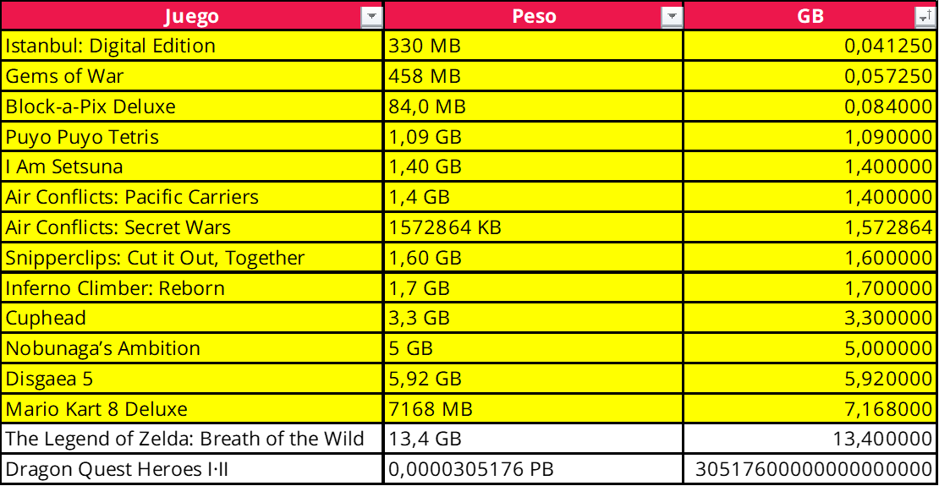

Instalamos 13 juegos ocupando un espacio total de 30.333364 GB: